AWS RDS TASK
- title: Create MariaDB DB on EC2.
objective: To install and configure a MariaDB database server on an EC2 instance, enabling secure database access for applications and validating connectivity by creating a sample database and user.
prerequisites:
aws account
ec2
mariadb and mysql packages installed
security groups
step by step process:
first, we need to launch an ec2 instance and connect it
we need to install mariadb now
yum update -y
dnf install -y mariadb105-server
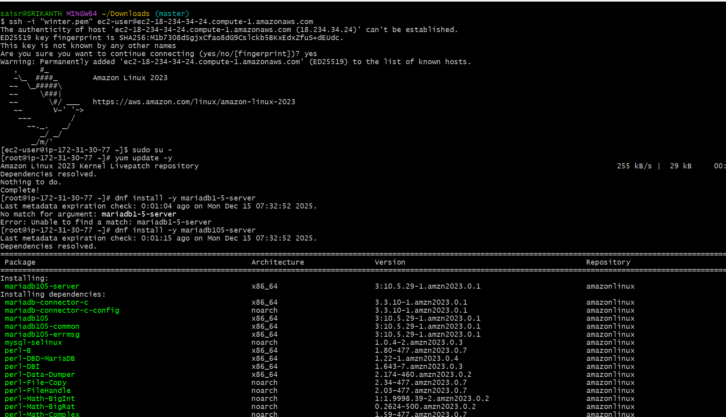
once it has been installed
we need to create user and password
DBName=myec2db
DBPassword=devops0509
DBRootPassword=devops0509
DBUser=myec2dbuser
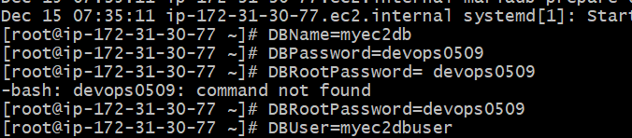
database set up on instance now
echo "CREATE DATABASE ${DBName};" >> /tmp/db.setup
echo "CREATE USER '${DBUser}' IDENTIFIED BY '${DBPassword}';" >> /tmp/db.setup
echo "GRANT ALL PRIVILEGES ON *.* TO '${DBUser}'@'%';" >> /tmp/db.setup
echo "FLUSH PRIVILEGES;" >> /tmp/db.setup
mysqladmin -u root password "${DBRootPassword}"
now if u got to tmp
validation steps:
cd /tmp/
to check the list use ls
you can see db.setup
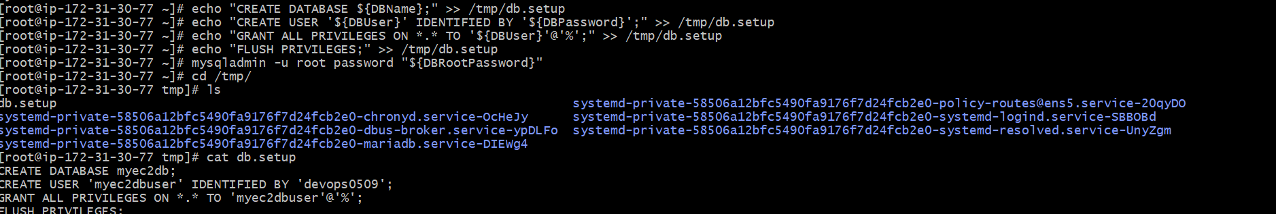
conclusion:
MariaDB installed and database created on ec2.
- Insert some dummy data.
objective: to insert some dummy data
prerequisites:
MariaDB
example creating ccricket
step by step process:
sql to create table and insert rows
to connect to database we use
mysql -u root --password="${DBRootPassword}"
to check database we use SHOW DATABASES;
now we are creating database cricket
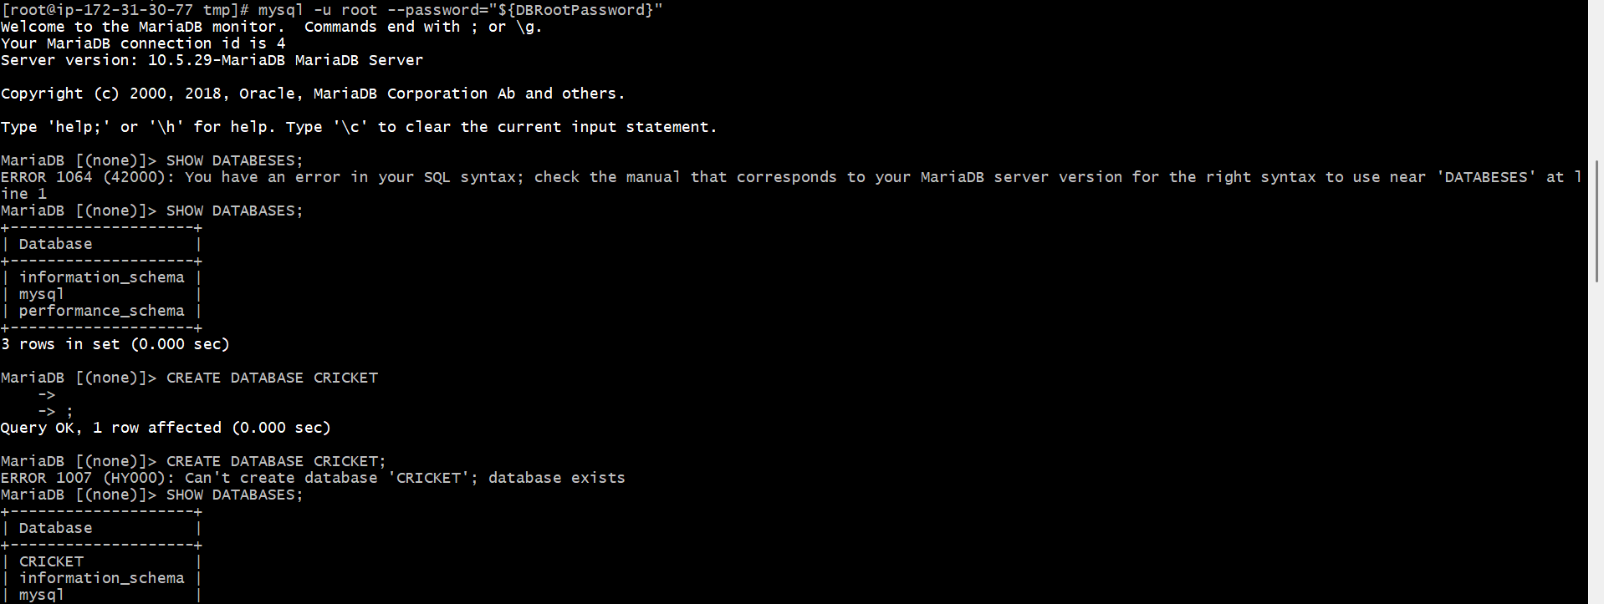
after creating database
to swtich to that databse
we nees to do USE CRICKET
validation steps:
now we are creating tables and inserting some values
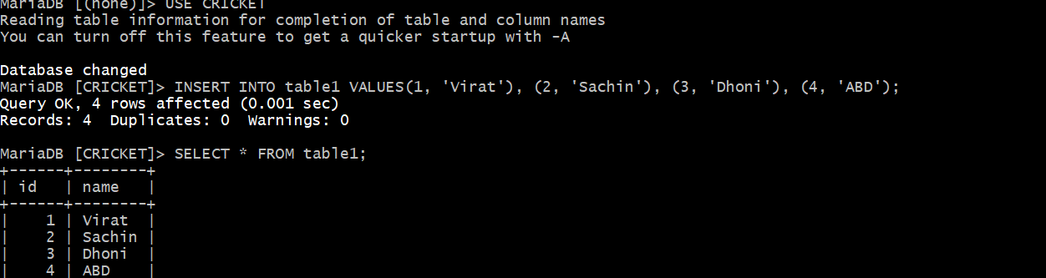
conclusion:
now dummy data has been created and inserted values in it
- Take the backup of dummy data on EC2.
objective: we need to create the backup (dump) for MariaDB in ec2
prerequisites:
MySQL available
step by step process:
mysqldump -u root -p CRICKET > Cricketbackup.sql
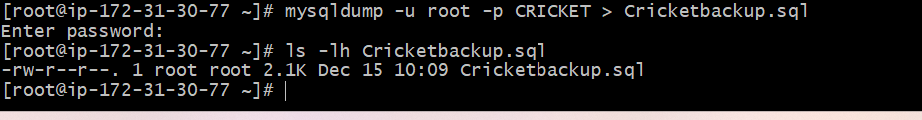
conclusion: backup MySQL Dump has been created in ec2.
- title: Launch MariaDB RDS instance.
objective: launching od MariaDB RDS instance in step-by-step process
prerequisites:
aws
RDS
ec2
step by step process:
got to rds console—create database—full configuration—select maria db
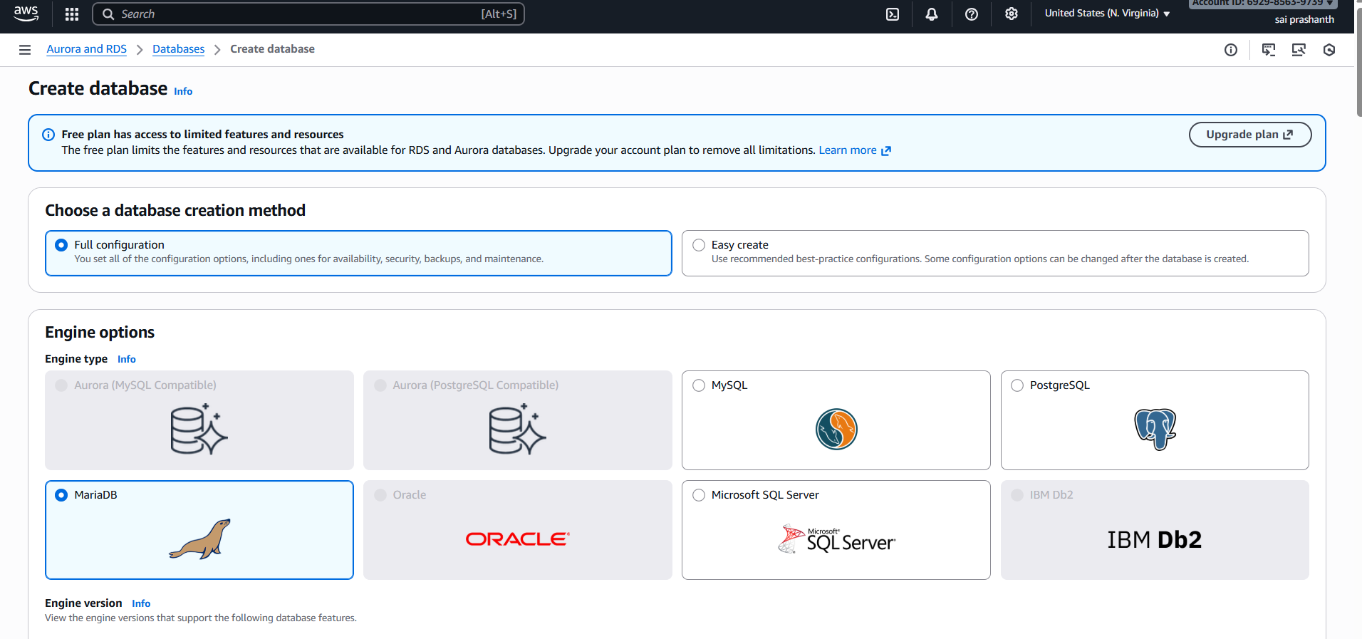
in settings—enter password which you have created already
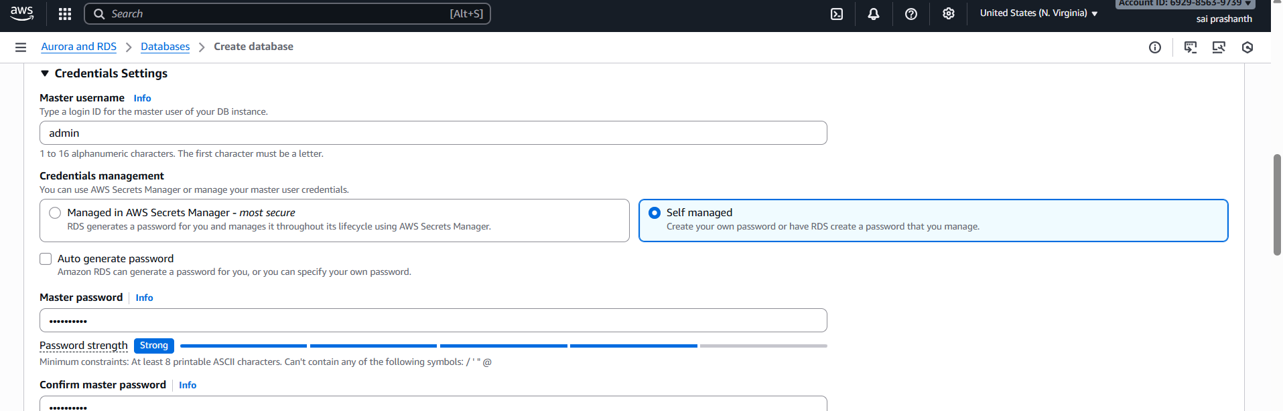
in storage—select general purpose—allocated storage 20gb
now we need to connect to ec2 instance
in connectivity—click on connect to ec2 instance
select your instance
then vpc chose existing
vpc security group—default

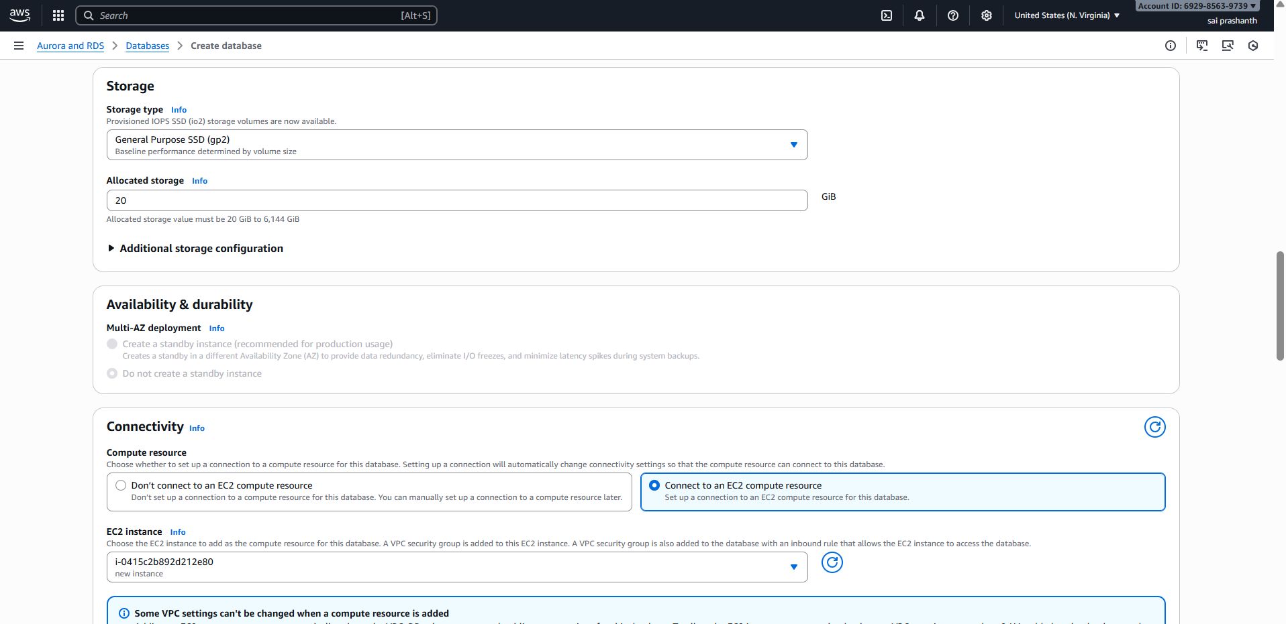
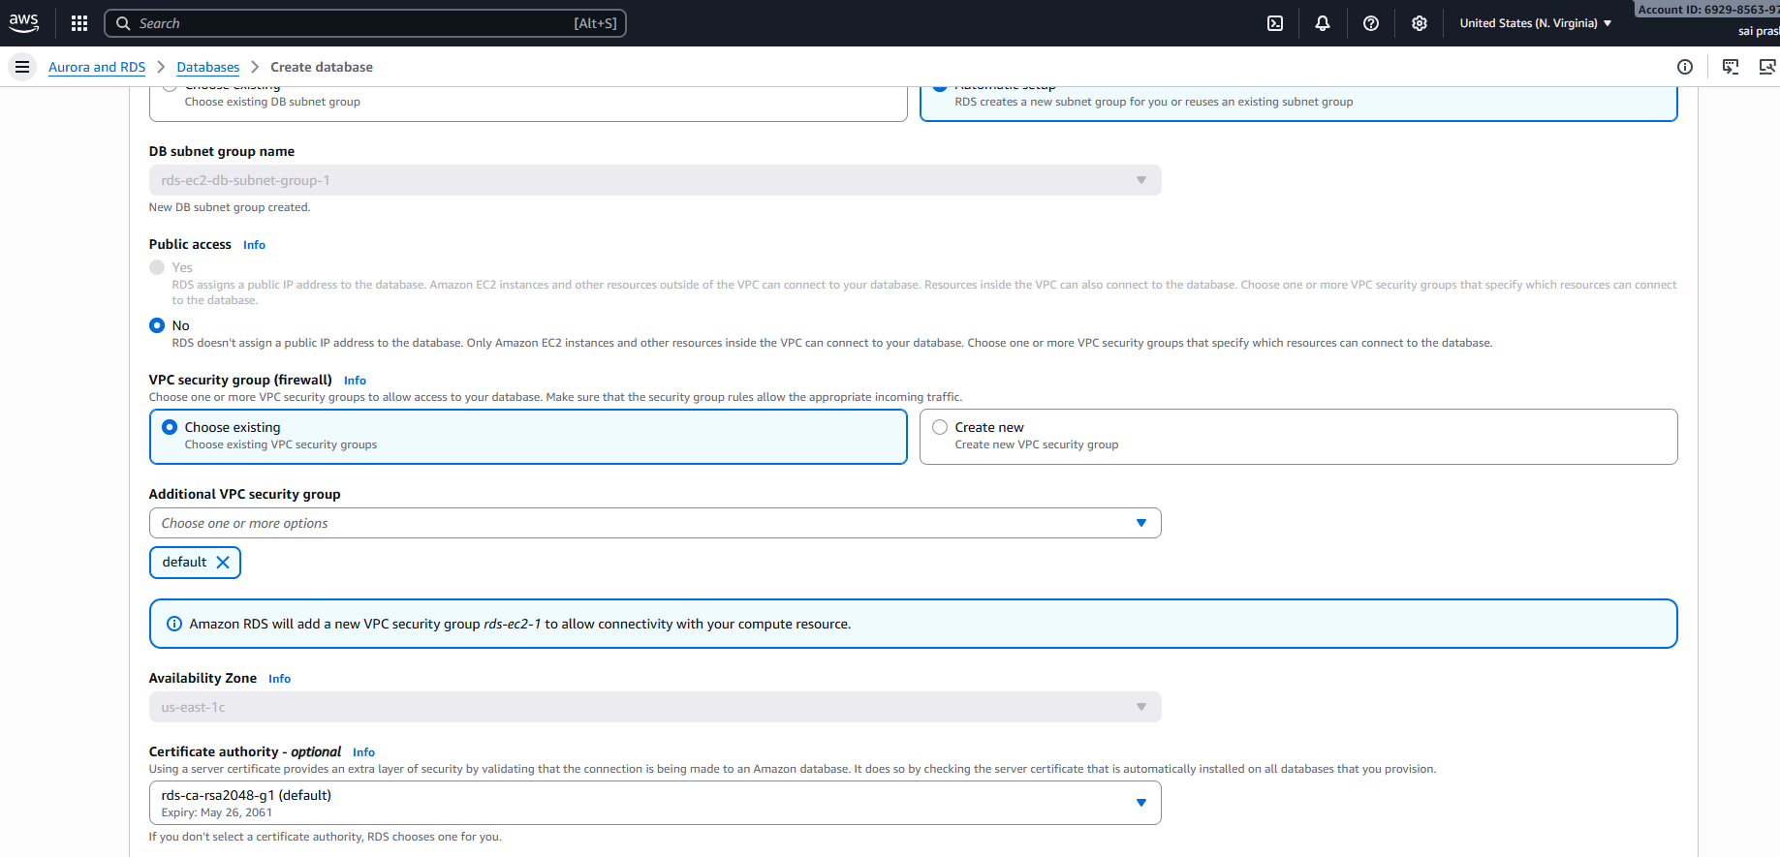
then in monitoring select database insights
click on create database
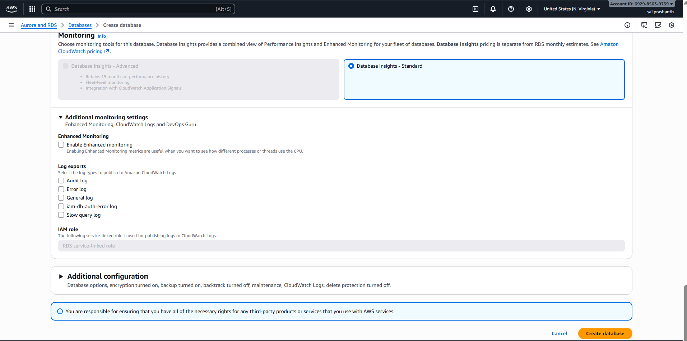
validation steps:
now you can see database has been created
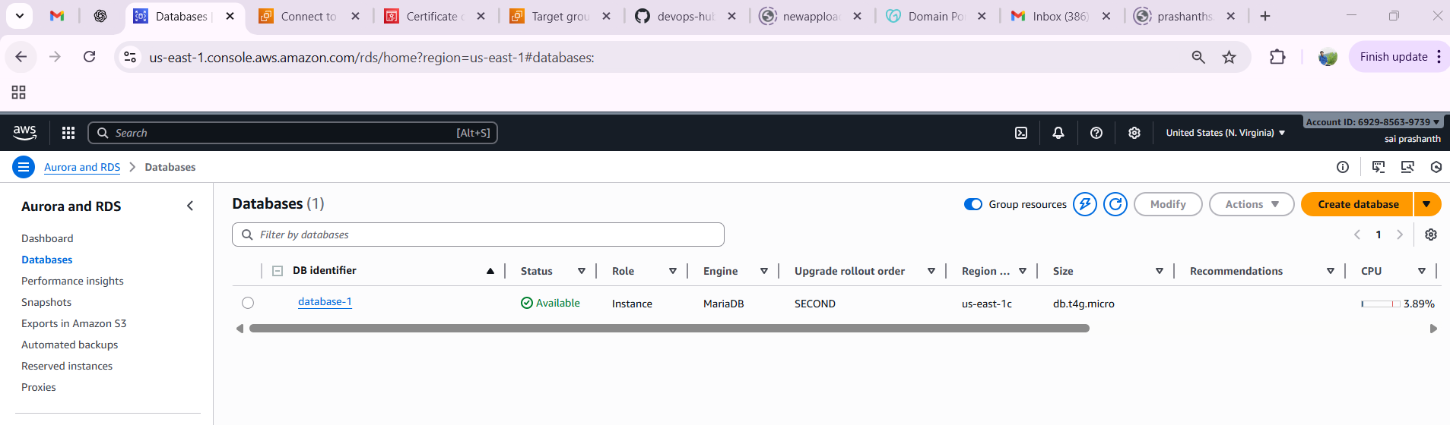
conclusion: now we have created database and it has connected to ec2
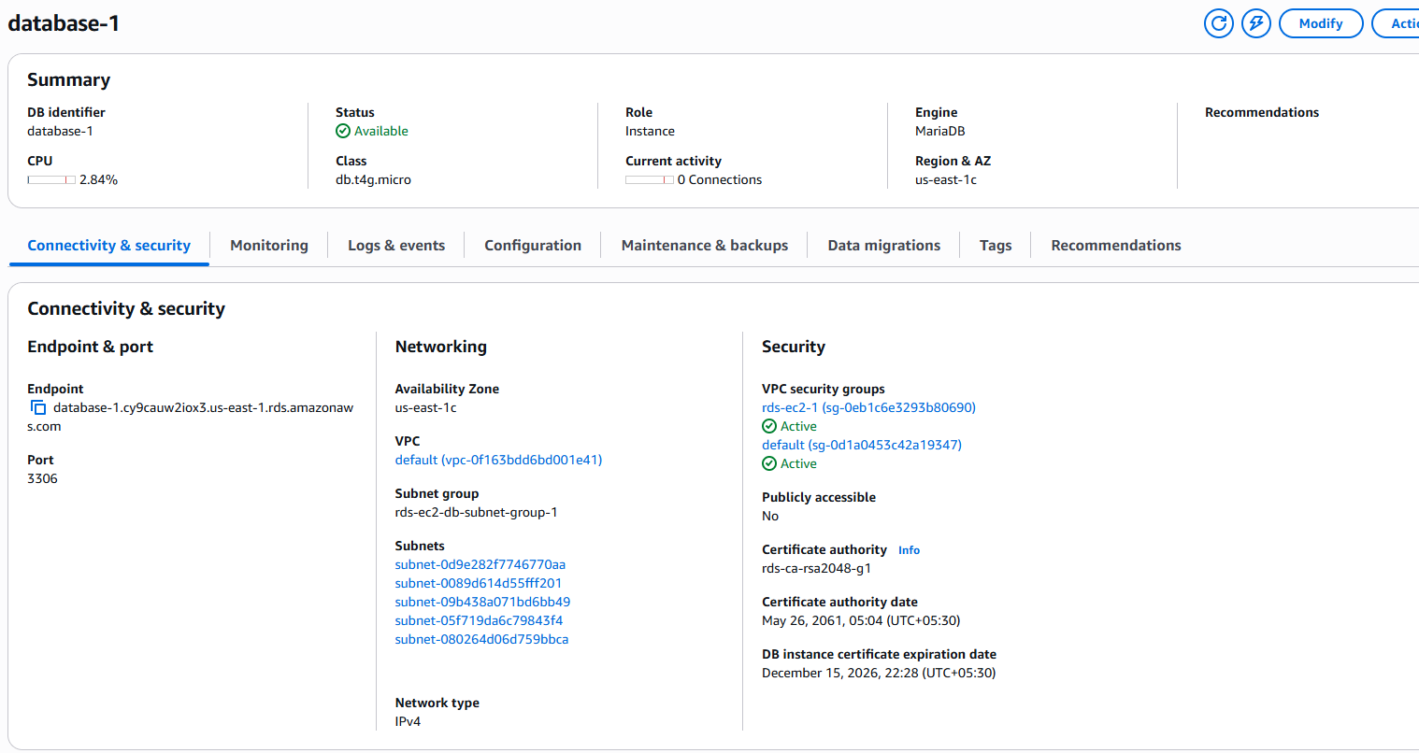
- Migrate database from EC2 to RDS.
objective: we need to migrate database from ec2 to rds
prerequisites:
- EC2 instance running in the same VPC as RDS
- MariaDB/MySQL installed on EC2
- AWS IAM permissions to create RDS and modify VPC security groups
- MySQL client installed on EC2
- A backup file available on EC2 (Techiebackup.sql)
step by step process
first, we need to create database how we created before with all configurations
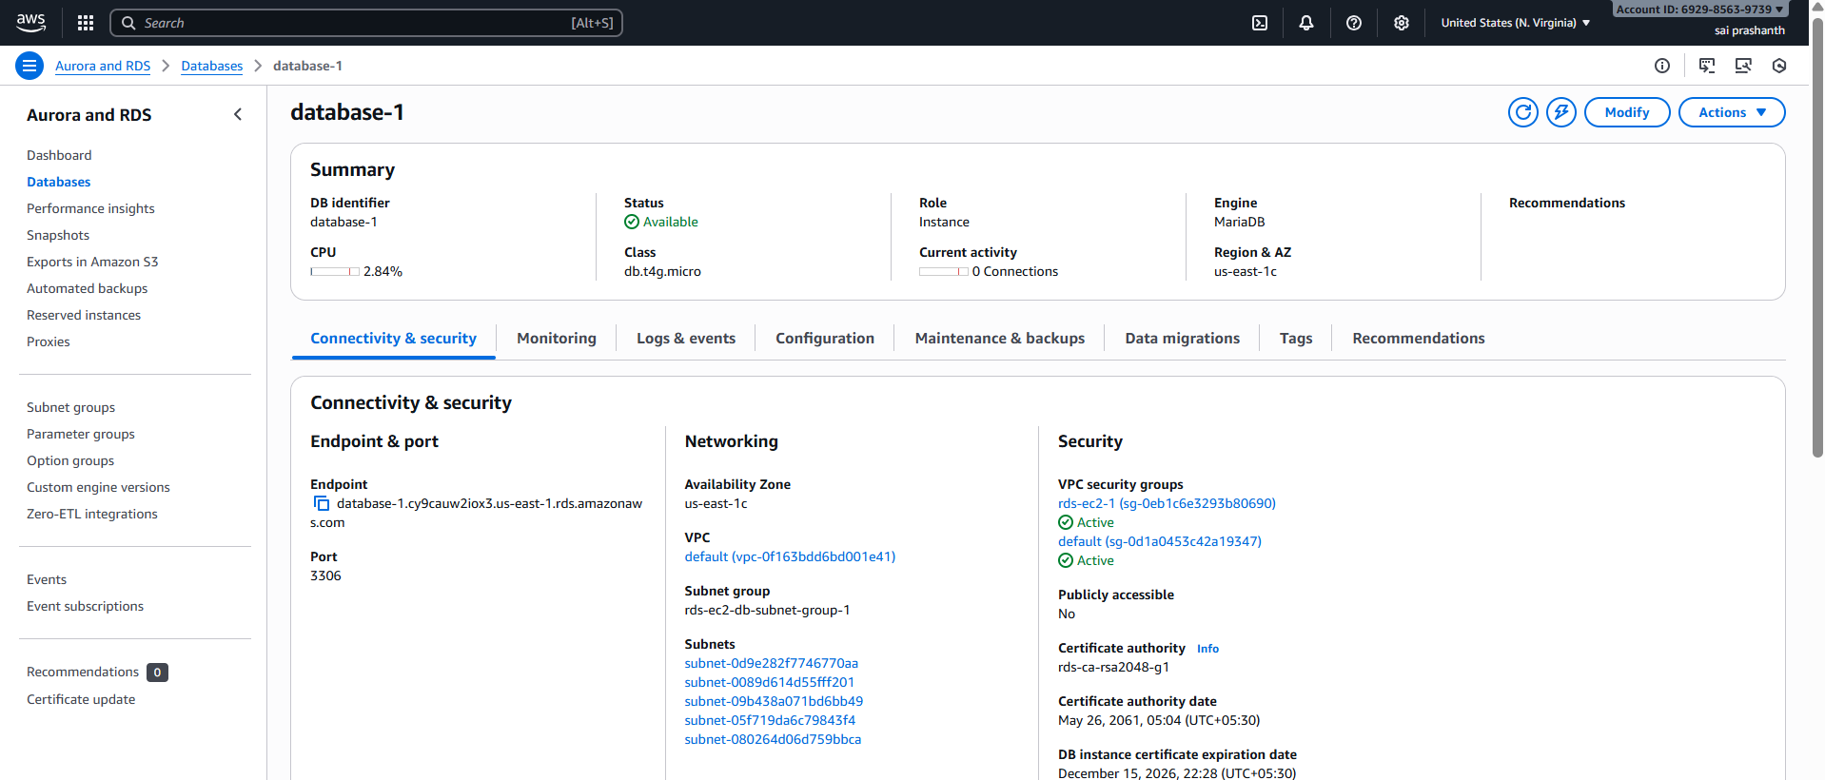
then go to ec2—select your instance—actions—networking—connect rds databse
once click on that connect—select instance—select your database
and click on connect
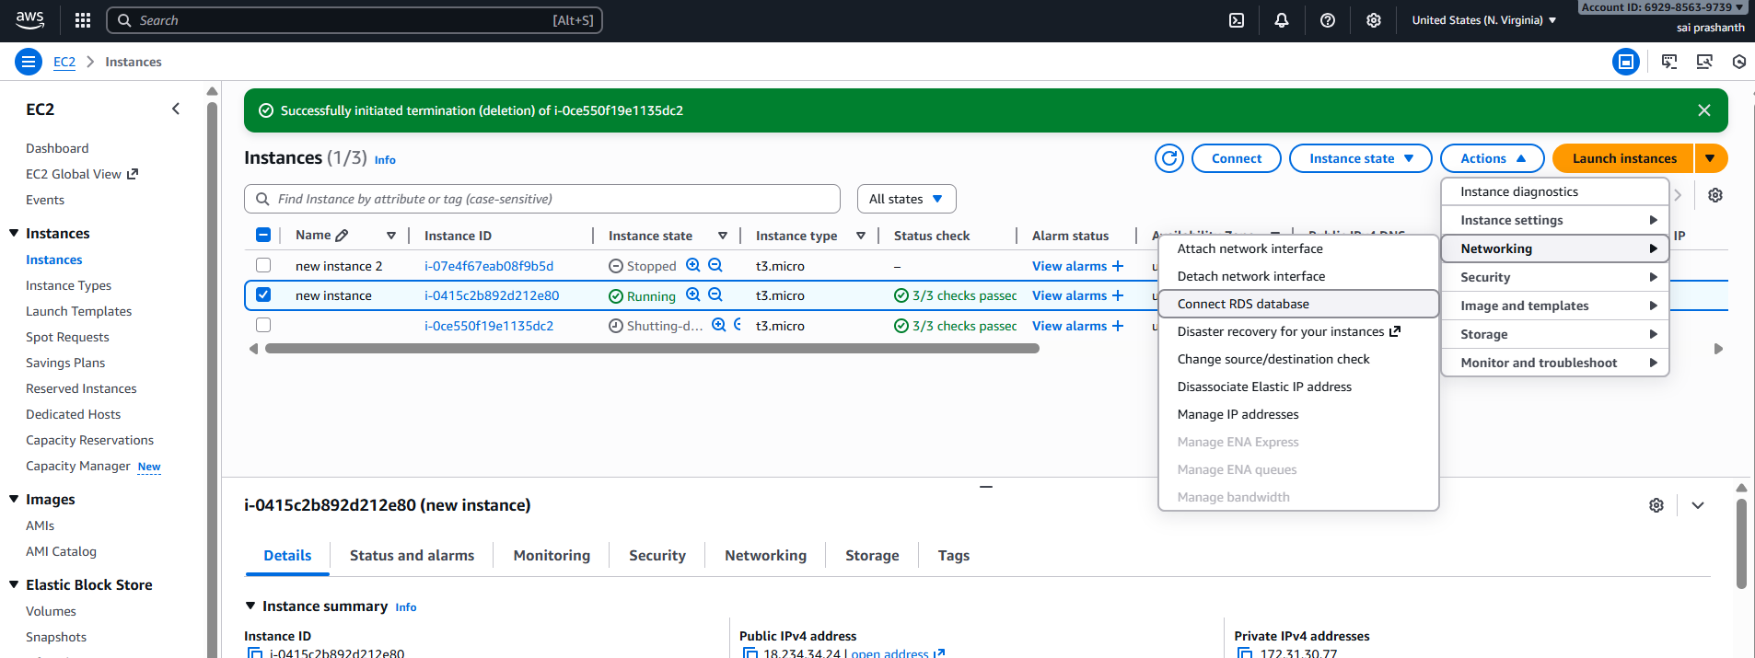
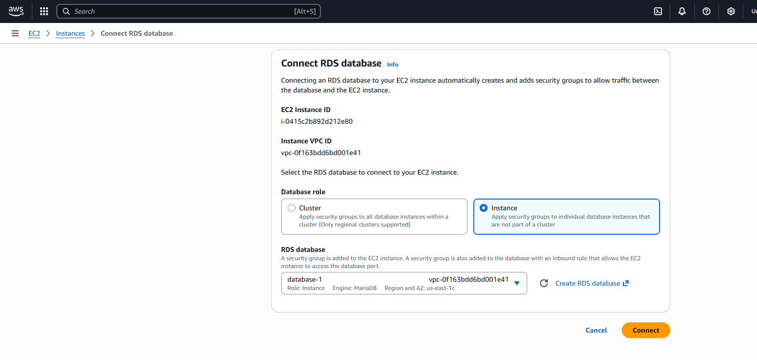
verification steps:
now we need to verify in CLI
ec2 has been migrated to rds
mysql -h <replace-rds-end-point-here> -P 3306 -u rdsuser -p
go to databases—seelct the end point link
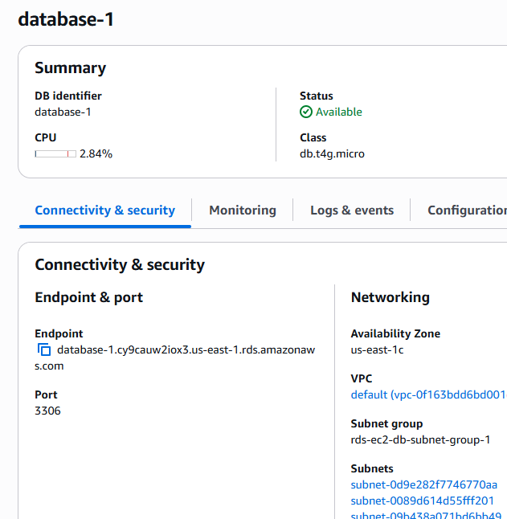

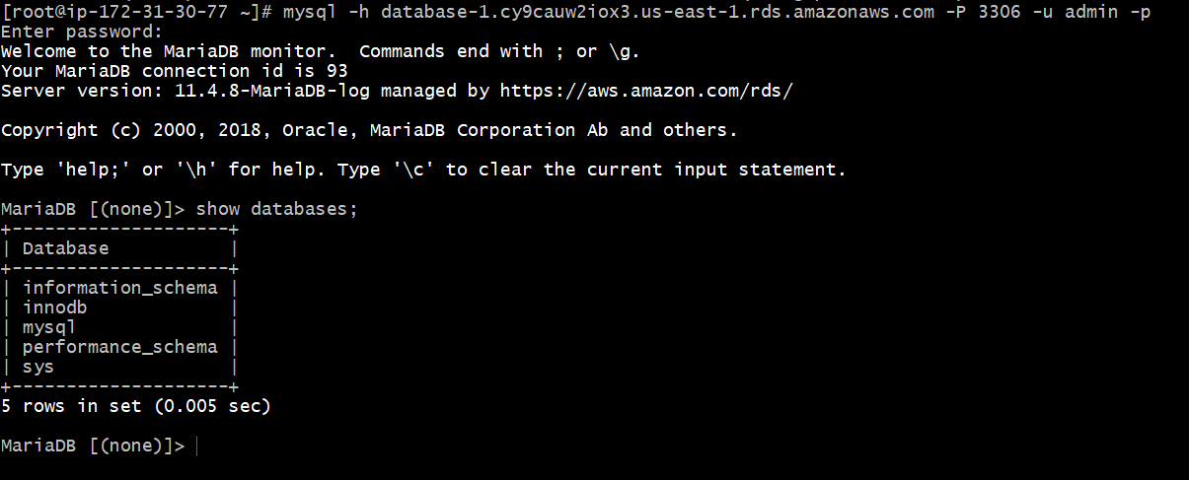
conclusion:
The migration from EC2 MariaDB → RDS MariaDB is complete and successful.

- title: Install MySQL DB on EC2.
objective: to install MySQL database in ec2 instance
prerequisites:
EC2 instance running Amazon Linux 2
Sudo privileges
Internet access (required to download MySQL repo package)
Basic CLI knowledge
step by step process:
to download and install the MySQL community release rpm
by busing command sudo dnf install https://dev.mysql.com/get/mysql80-community-release-el9-1.noarch.rpm -y
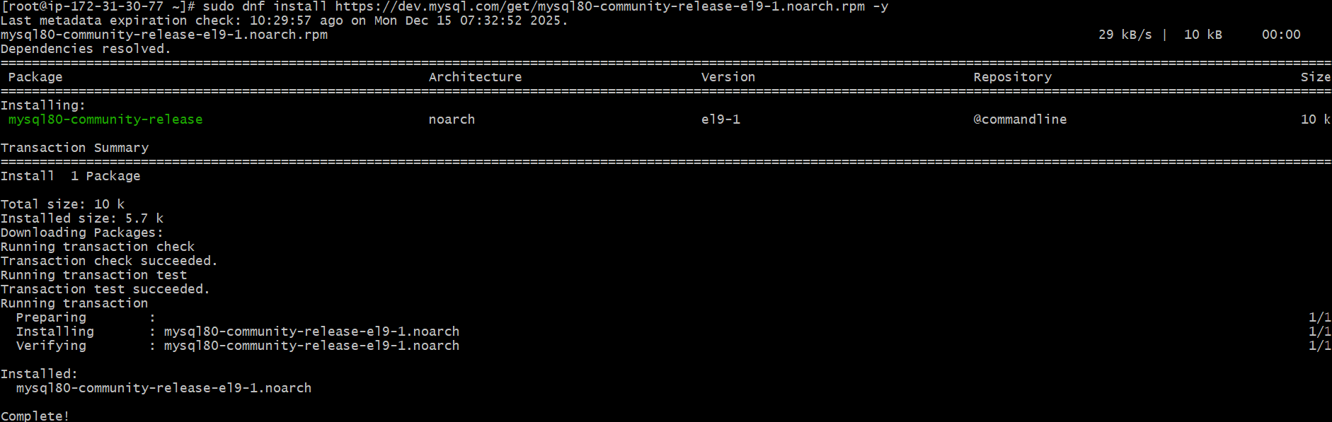
now to enable mysql community
used command sudo dnf config-manager --enable mysql80-community
installed mysql community server now
used command sudo dnf --skip-broken install mysql-community-server -y
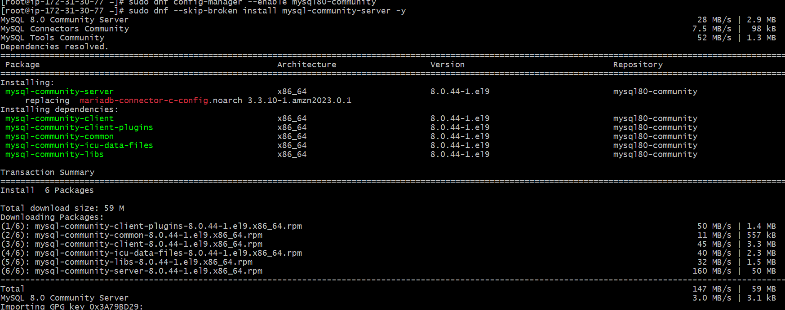
verification status:
now verified the status of MySQL server has been active or not
systemctl status MySQLd
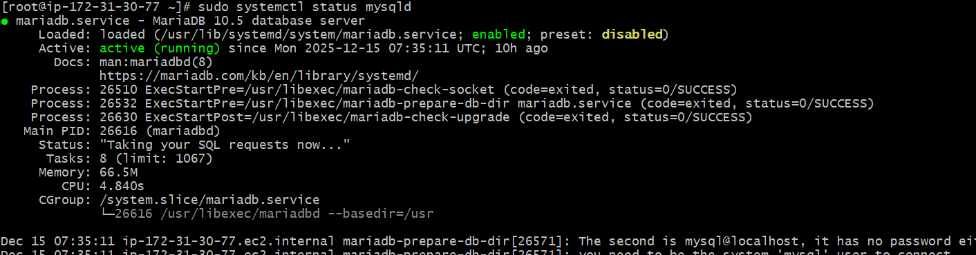
conclusion:
mysql has been installed in database
Installed MySQL Server packages
Checked the running database service
- title: Launch MySQL RDS image.
objective: To create two Amazon RDS database instances—one MariaDB and one MySQL—configure their settings, connect them to an existing EC2 instance, and ensure that both databases are accessible for future migration and testing.
prerequisites:
AWS Account
IAM user with RDSFullAccess
VPC (default or custom)
Subnets (minimum 2 for Multi-AZ)
Security Group allowing MySQL (3306)
Key Pair (not mandatory for RDS)
step by step process:
first go to rds---database—create database—select mysql
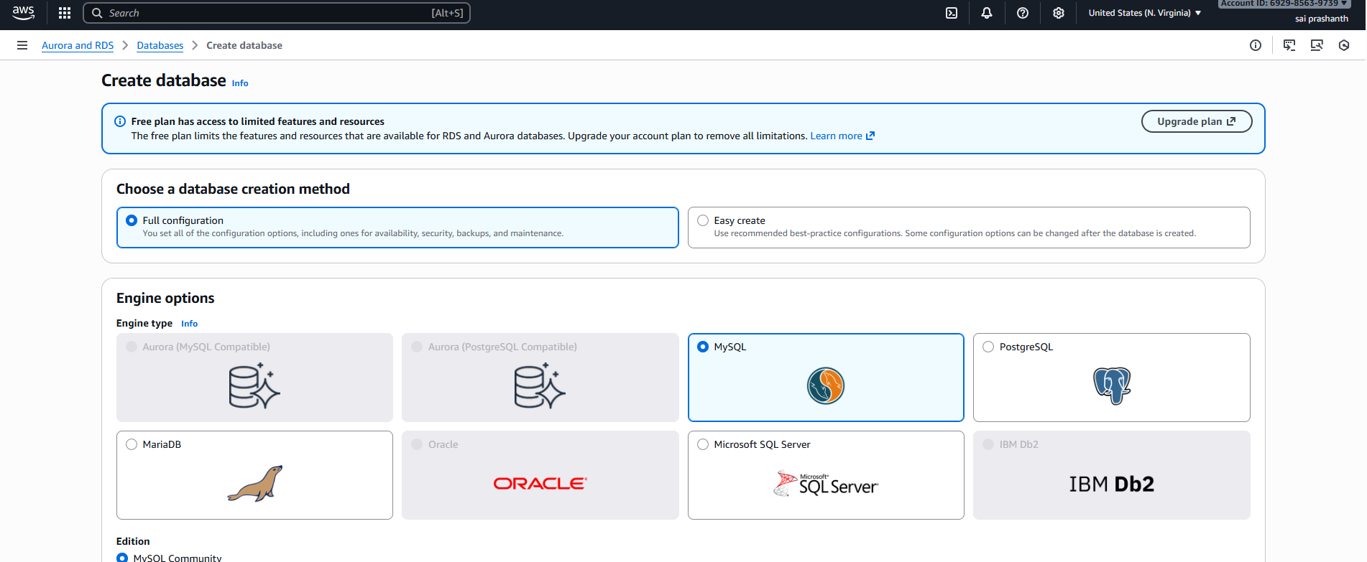

select free tier in templates and availability zone as single Az
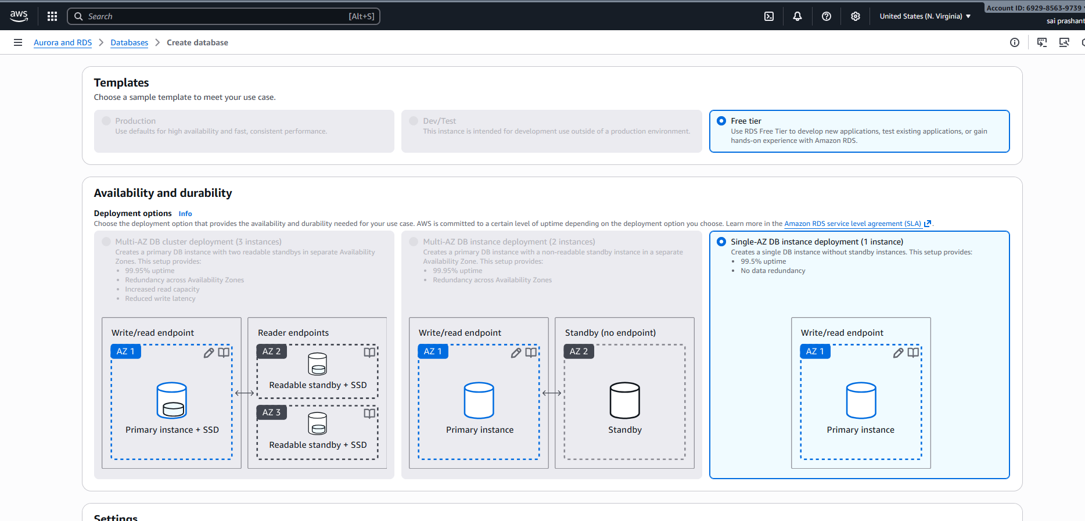
in settings---selefmanaged---enter the password what you have created
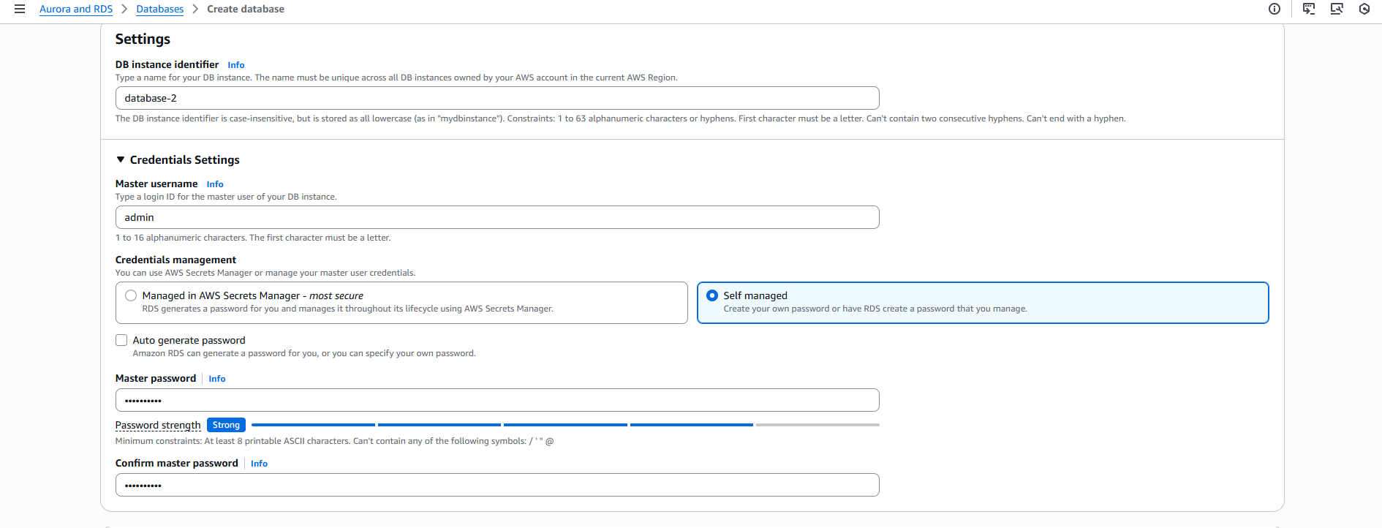
in storage type—select general purpose—allocated storage 400 gb as there is more by default
connect to existing instance
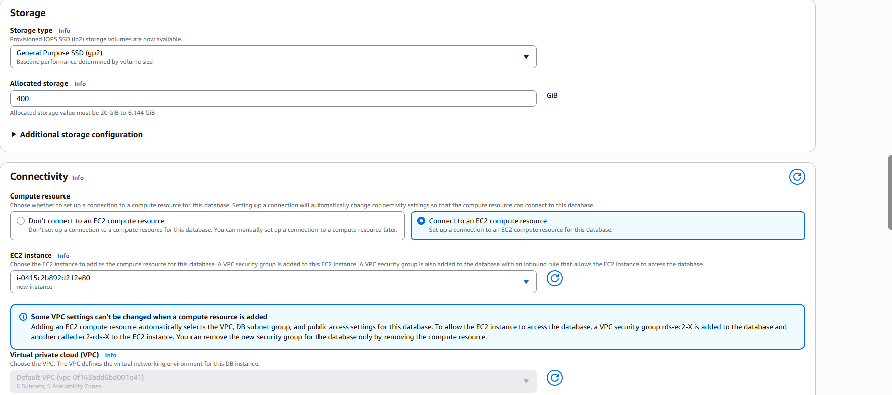
choose security group default one existing only
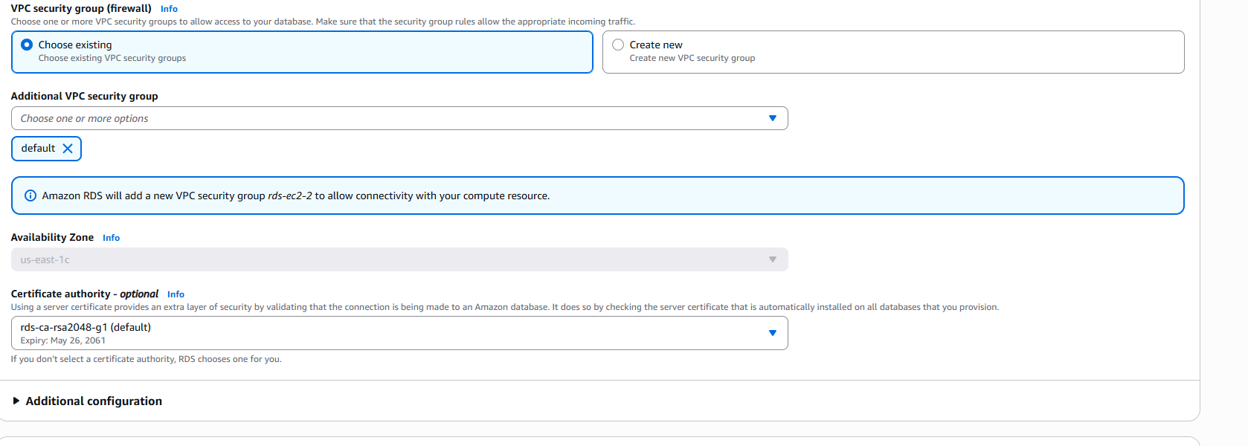
select database insight standard only—click on create database
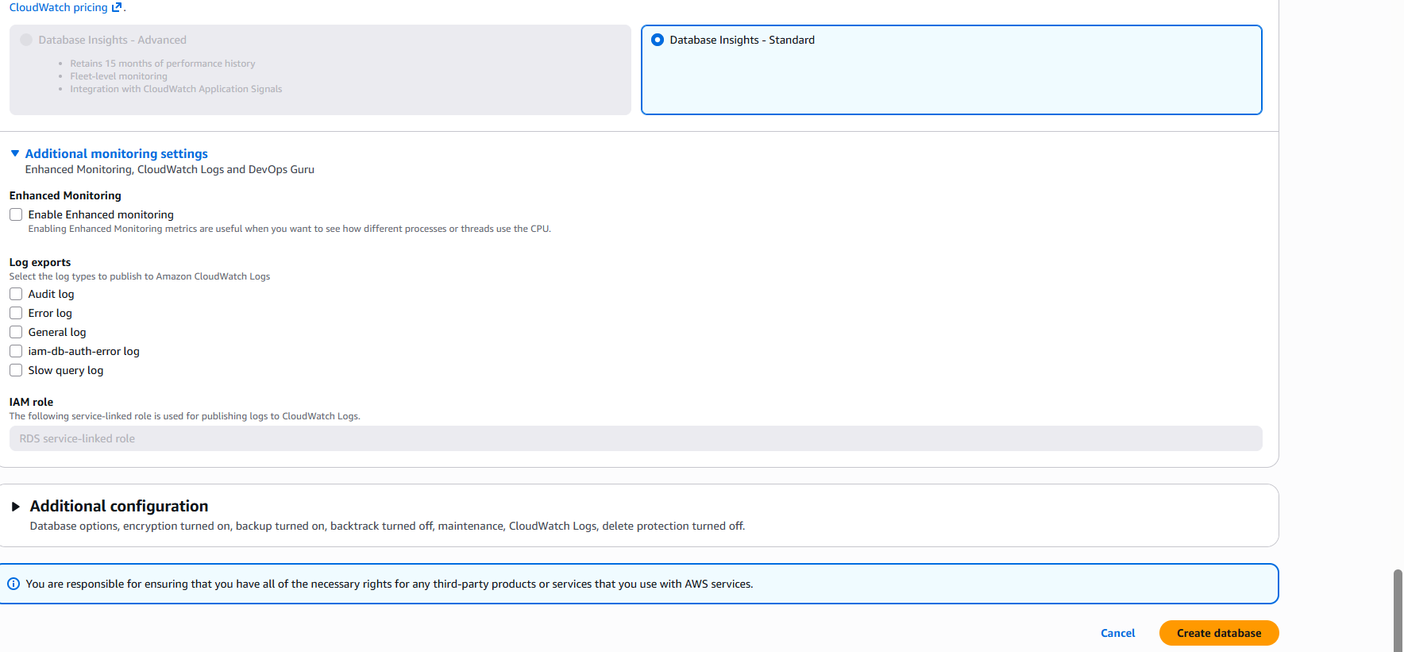
verification steps:
MySQL database has been created
now you can see two databases has been created one is MariaDB and MySQL
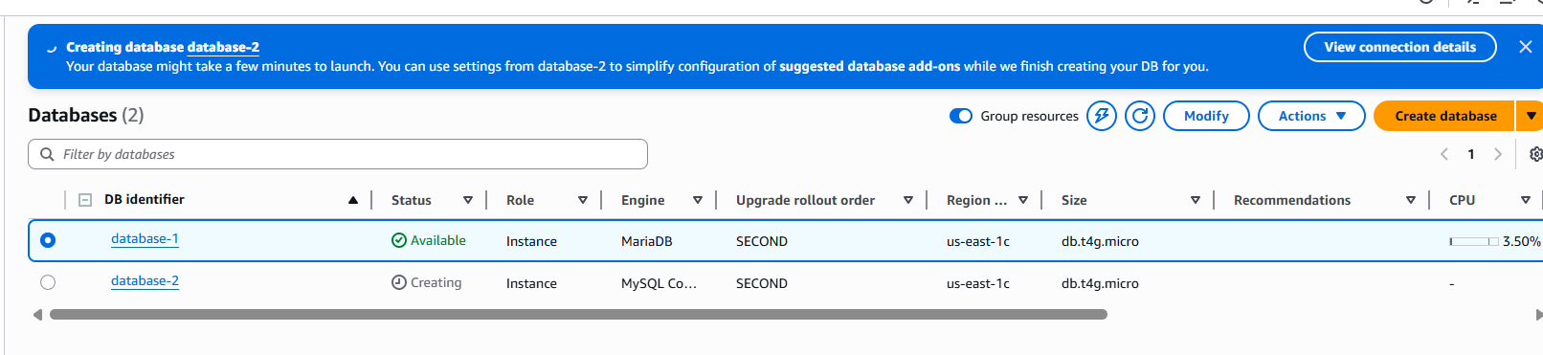
conclusion:
now you can see mysql database has been created
- title: Take backup of DB and restore the DB.
objective: To take a backup of a MySQL/MariaDB database and restore it successfully in case of data loss or migration.
prerequisites:
Two RDS databases
Proper IAM permissions to create manual RDS snapshots.
RDS instance must be in Available or Backing-up state.
step by step process:
first go to rds—databases—you can see two databases which have been created
now we need to created backup means snapshot for both the databases
go to actions—seelct take snap shot
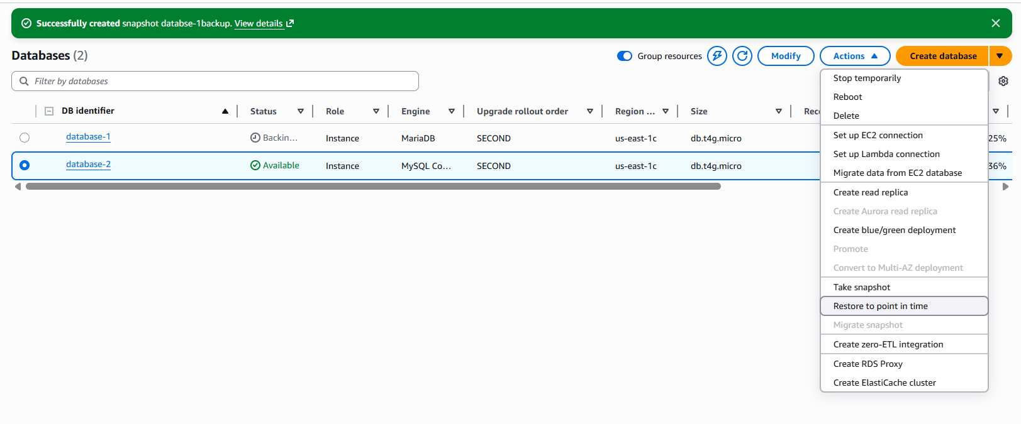

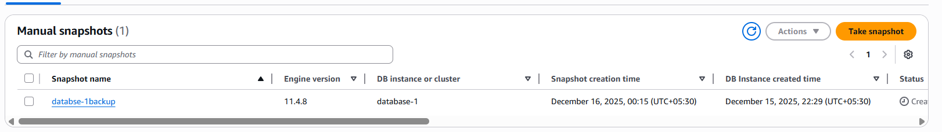
for two databses give two two names
databse-1backup and databse-2backup
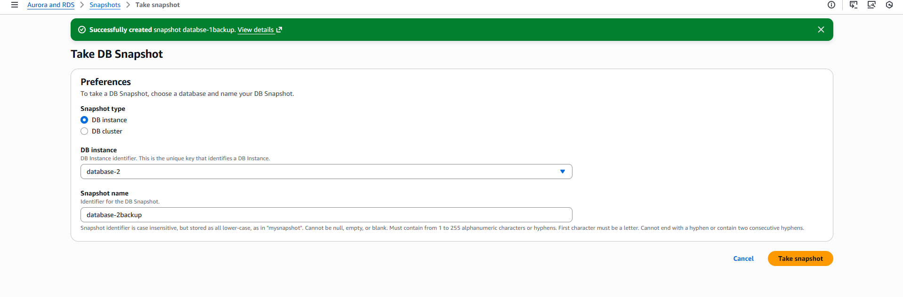
validation steps:
now you can see two backups has been created.
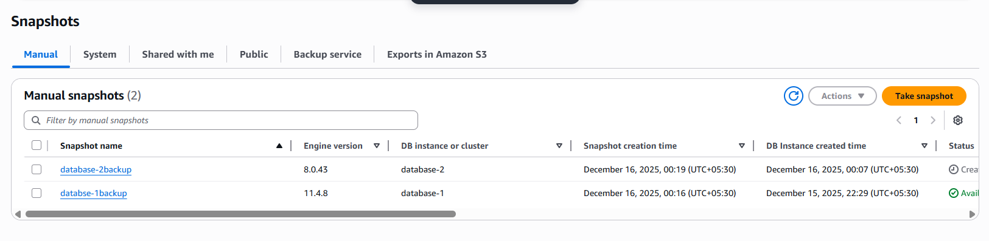
conclusion:
successfully created two backups or snapshots for both databases.
- title: Create read replica.
objective: To create a read replica for the RDS instance (database-1) to offload read workloads and improve performance
prerequisites:
rds database
free aws account
db engine must support read replica
step by step process:
first go to rds—select one database—actions—click on create replica
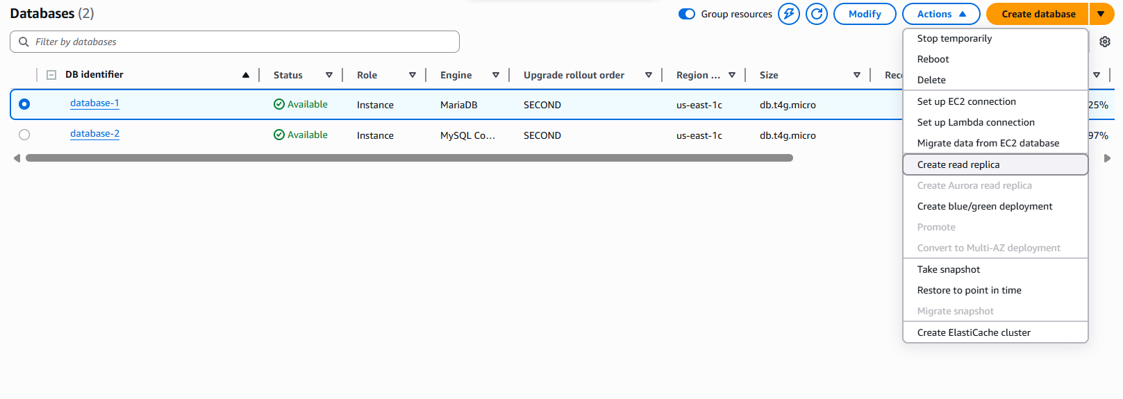
now after clicking enter replica name
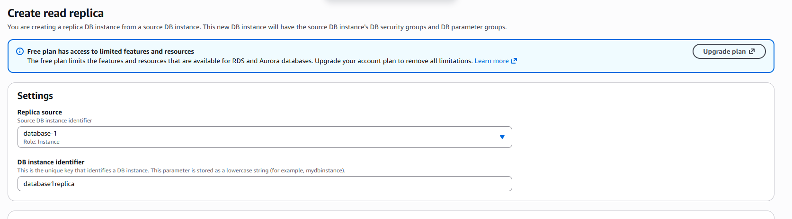
select your storage and region
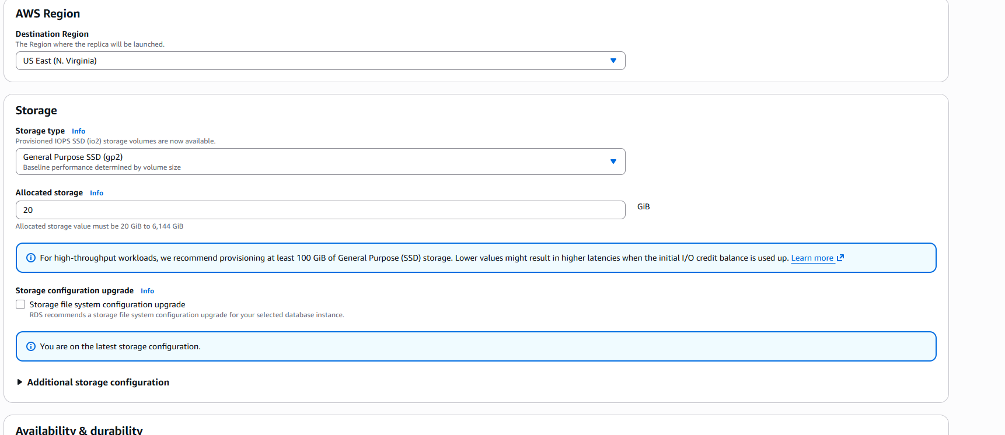
se;ect connectivity ipv4
vpc security groups select default and ec2-1 as you have created earlier
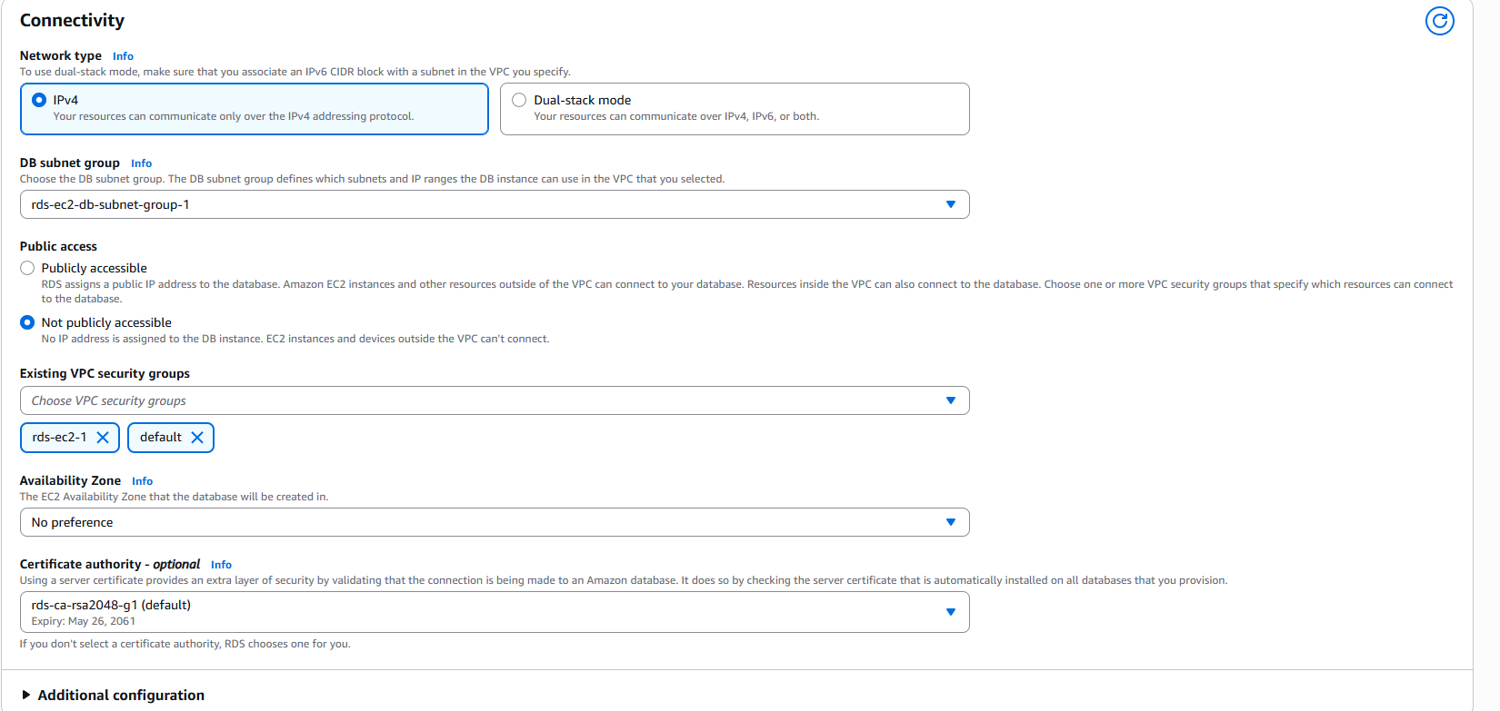
databse monitoring---select standard
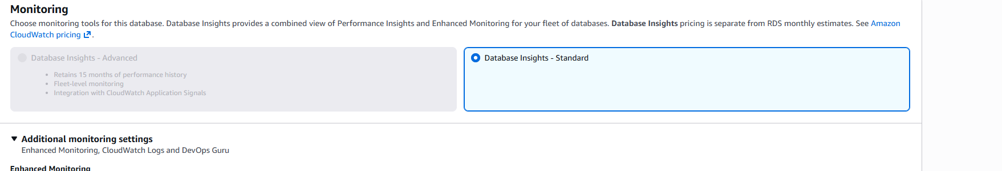
now click on create replica
it was not created
error:
it’s getting error like reached maximum instances has been created with free plan
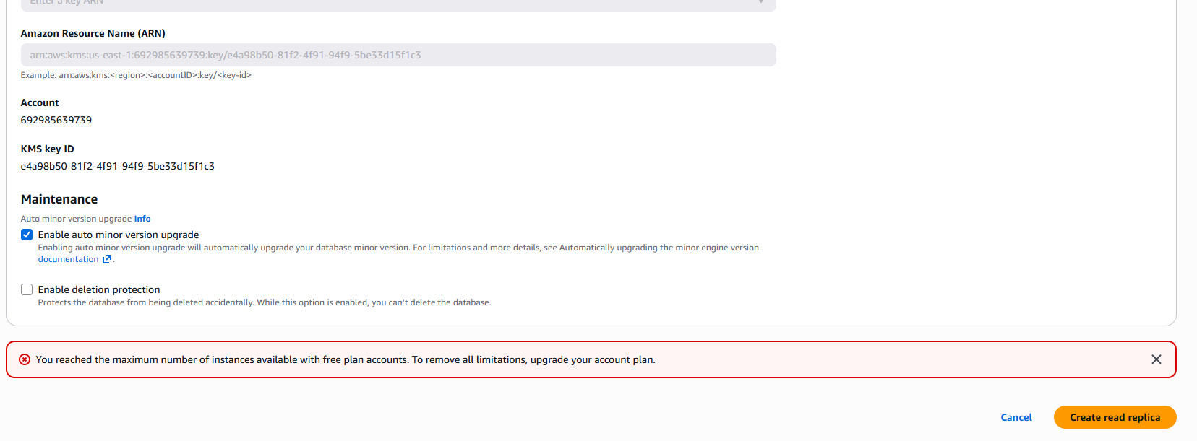
conclusion: these are the steps we need to follow to create replica as here its not created due to reached maximum limit

